**Chapter 10:**

**Organizing:**

* Arranging and structuring work to accomplish an organization’s goals.

**Organizational Structure:**

* The formal arrangement of jobs within an organization.
* Involves dividing, grouping, and coordinating job tasks.

**Purposes of Organizing**

* Divides work into specific jobs and departments.
* Assigns tasks and responsibilities.
* Coordinates diverse organizational tasks.
* Clusters jobs into units.
* Establishes relationships among individuals, groups, and departments.
* Establish formal lines of authority.
* Allocates and deploys organizational resources.

**Organizational Structure (Henry Mintzberg)**

* Formal framework by which jobs and tasks are divided, grouped, and coordinated.
* Formal reporting relationships.
* Design of systems to ensure effective coordination.

**Organizational Chart (Hierarchy or Organogram):**

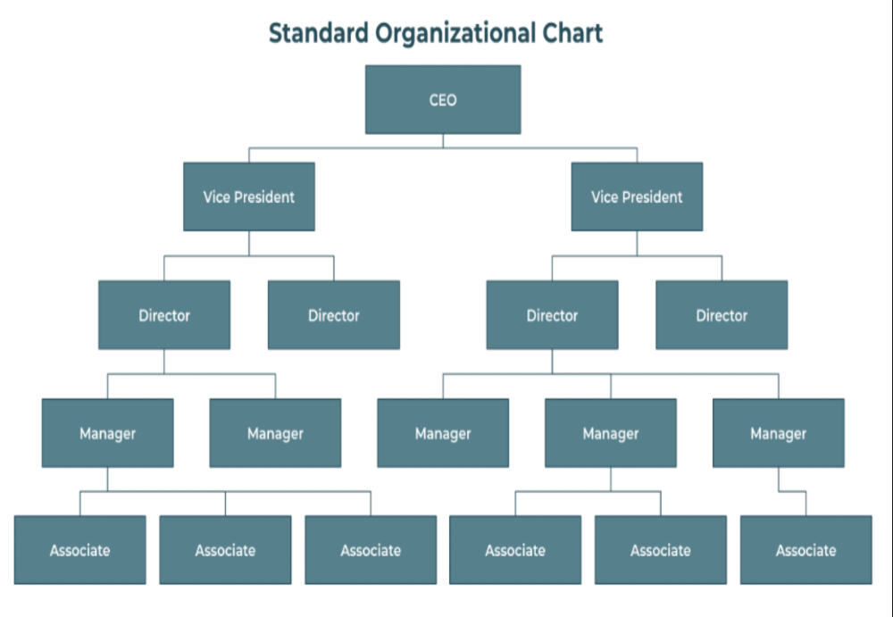

1. **Work Specialization:**
   * Dividing work activities into separate tasks.
   * Increase efficiency and productivity.
   * Example: McDonald’s fast-food preparation.
2. **Departmentalization:**
   * Organizing workload into manageable units.
   * Types: Process, Customer, etc.
   * Need: Improves coordination, control, and accountability.

**Types of Departmentalization:**

**i. Functional Departmentalization**

* **Based on:** Functions or job roles (e.g., Marketing, Finance, HR, Operations)
* **Example:** A company has separate departments for Accounting, Sales, and Customer Service.
* **Advantage:** Specialization and efficiency in each function.

**ii. Product Departmentalization**

* **Based on:** Products or product lines.
* **Example:** A clothing company has departments for Men’s Wear, Women’s Wear, and Kids’ Wear.
* **Advantage:** Focus on product performance and customer needs.

**iii. Geographical Departmentalization**

* **Based on:** Location or regions.
* **Example:** A company has divisions for North America, Europe, and Asia.
* **Advantage:** Better local service and decision-making.

**iv. Customer Departmentalization**

* **Based on:** Types of customers served.
* **Example:** A bank may have departments for individual customers, small businesses, and corporate clients.
* **Advantage:** Tailored services for specific customer groups.

**v. Process Departmentalization**

* **Based on:** Production or service processes.
* **Example:** A manufacturing firm has departments for cutting, assembling, and packaging.
* **Advantage:** Efficiency in handling similar tasks.

1. 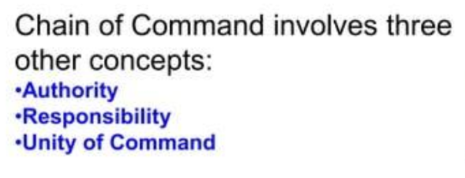**Chain of Command:**
   * Line of authority from top management to lowest ranks.
   * **Line Authority**: Gives the power to give orders and expect them to be followed, Directly involved in achieving the main goals of the organization.
   * **Staff Authority**: This is the authority given to support or advise the line managers. Staff members help by giving expert advice, but they don’t give direct orders to workers.

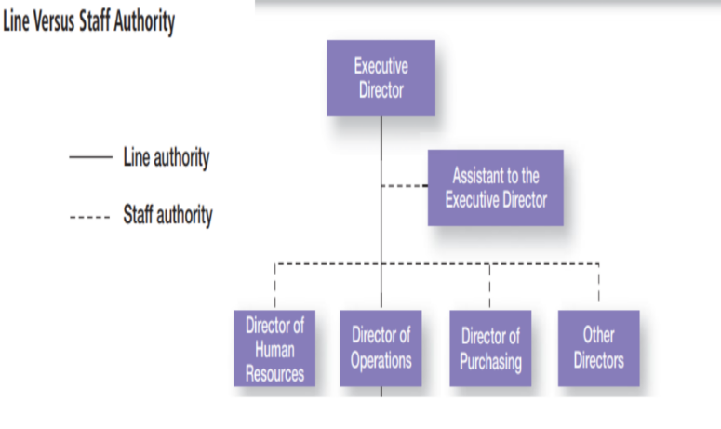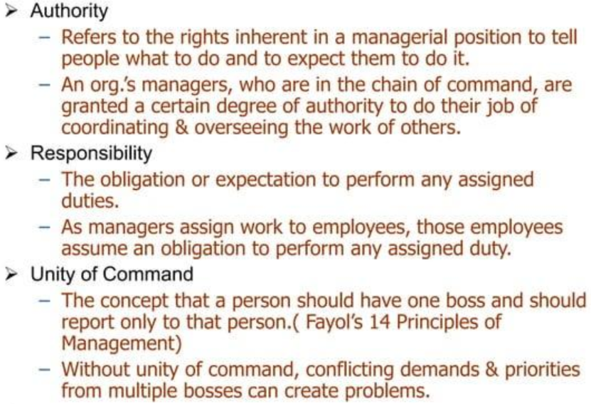

1. 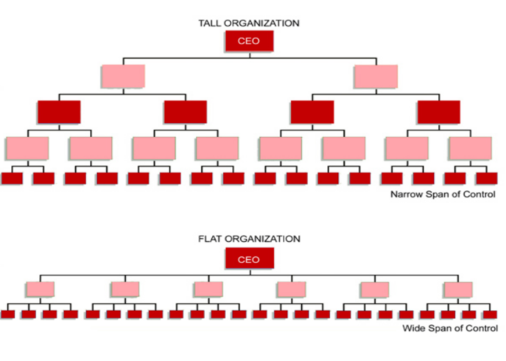**Span of Control:**
   * The number of employees a manager can effectively manage.
   * **Narrow vs. Wide Span:**
     + **Narrow**: Fewer employees, more levels (Tall Organization).
     + **Wide**: More employees, fewer levels (Flat Organization).
   * **Factors**: Skills, task complexity, culture, technology.
2. **Centralization and Decentralization:**
   * **Centralization**: Concentration of decision-making at higher levels.

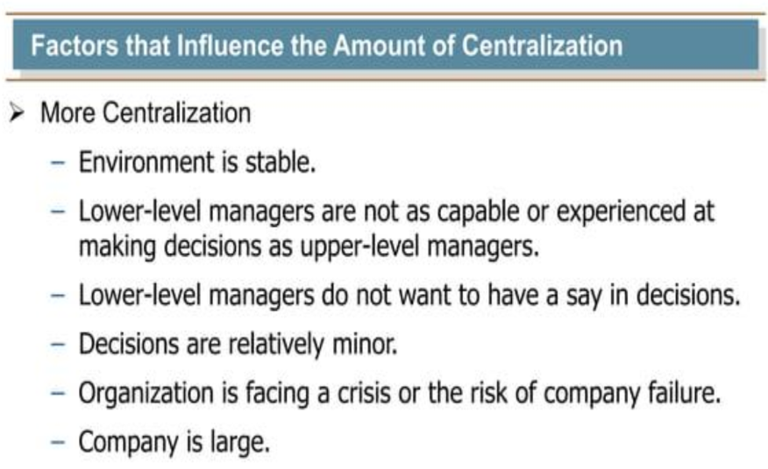

* + **Decentralization**: Distribution of decision-making across levels.

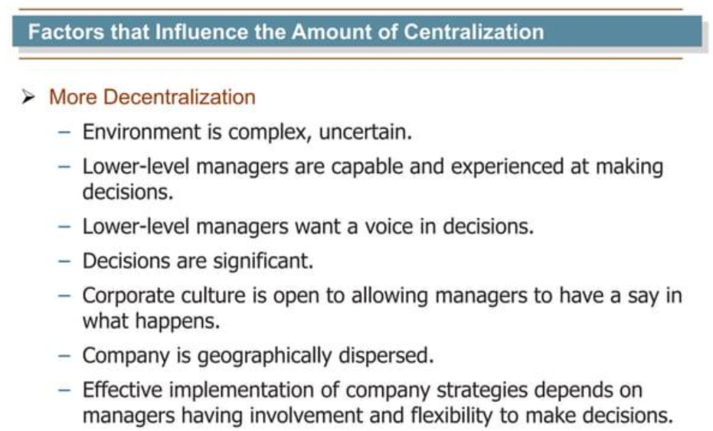

1. **Formalization:**
   * Degree to which jobs are standardized and guided by rules and procedures.
   * **High** **Formalization**: Many rules defined procedures.
   * **Low** **Formalization**: More caution for employees.

**Questions & Answers**

**Scenario 1:**

A fast-food restaurant is looking to improve its efficiency. The manager decides to divide the tasks among employees such that one person takes orders, another prepares drinks, and a third cooks the food.

**1. What concept is the manager applying in this scenario?**

- A) Departmentalization

- B) Centralization

- C) Work Specialization

- D) Formalization

**Answer: C) Work Specialization**

**Scenario 2:**

A textile company organizes its operations into separate departments for spinning, weaving, and dyeing. Each department is responsible for its specific part of the production process.

2. What type of departmentalization is being used here?

- A) Customer Departmentalization

- B) Process Departmentalization

- C) Functional Departmentalization

- D) Product Departmentalization

**Answer: B) Process Departmentalization**

**Scenario 3:**

A software company has a manager who oversees a team of 15 developers. The company is considering restructuring to have managers oversee smaller teams of 5 developers each.

**3.** What change in the span of control is the company considering?

- A) Increasing the span of control

- B) Decreasing the span of control

- C) Maintaining the span of control

- D) Eliminating the span of control

**Answer: B) Decreasing the span of control**

**Scenario 4:**

In a manufacturing company, the production manager has the authority to direct the work of the assembly line workers, while the HR manager provides advice on employee policies but does not direct the production process.

4. Which of the following best describes the roles?

- A) The production manager has staff authority, and the HR manager has line authority.

- B) The production manager has line authority, and the HR manager has staff authority.

- C) Both managers have line authority.

- D) Both managers have staff authority**.**

**Answer: B) The production manager has line authority, and the HR manager has staff authority.**

**Scenario 5: Formalization**

A tech startup has few formal rules and allows employees to make decisions autonomously, while a traditional bank has detailed procedures for every task.

5. Which organization has a higher level of formalization?

- A) The tech startup

- B) The traditional bank

- C) Both have the same level of formalization

- D) Neither has formalization

Answer: B) The traditional bank

**---**

**Question-Answer Pairs**

**1. What is the primary purpose of an organizational chart?**

- Answer: An organizational chart is a visual tool that represents a company’s internal structure, detailing how teams and departments are organized and how relationships flow across the organization. It outlines individual roles and responsibilities and clarifies the hierarchy and reporting lines within the business.

**2. Explain the difference between mechanistic and organic organizational structures.**

- Answer: Mechanistic structures are rigid and hierarchical, with clear lines of authority and communication. They are typically bureaucratic and suitable for stable environments. Organic structures are flexible and adaptable, with less formal structure and more fluid communication. They are better suited for dynamic and changing environments.

**3. How does departmentalization improve coordination within an organization?**

- Answer: Departmentalization improves coordination by organizing the workload into manageable units or departments, each responsible for specific tasks. This structure facilitates better communication and collaboration between departments, ensuring a smooth workflow and clear accountability.

**4. What factors influence the span of control within an organization?**

- Answer: Factors influencing the span of control include the skills and abilities of the manager and employees, the complexity of tasks, the organizational culture, and the use of technology. These factors determine whether an organization adopts a narrow or wide span of control.

**5. Why is work specialization important in organizations like McDonald's?**

- Answer: Work specialization is important in organizations like McDonald's because it allows employees to focus on specific tasks, increasing efficiency and productivity. By dividing tasks such as taking orders, cooking, and assembling food among different employees, McDonald's can serve customers quickly and efficiently.

*More Case Studies Questions ---*

**Case Study 1: Restructuring a Retail Company**

**Case Description:**

A retail company, "FashionHub," has been experiencing inefficiencies in its operations. The company currently has a flat organizational structure with a wide span of control, where managers oversee large teams. The CEO is considering restructuring the company to improve coordination and accountability.

**Question 1:**

What type of organizational structure should the CEO consider implementing to improve coordination and accountability? Explain your reasoning.

**Answer**:

The CEO should consider implementing a tall organizational structure with a narrower span of control. This structure would involve more levels of management, with each manager overseeing fewer employees. This change would likely improve coordination by providing more focused supervision and clearer lines of communication. Additionally, a narrower span of control can enhance accountability as managers can more effectively monitor and support their team members.

**Question** **2:**

How might departmentalization by product lines benefit FashionHub?

**Answer**:

Departmentalization by product lines would allow FashionHub to focus on specific customer segments and tailor their strategies accordingly. This approach can improve responsiveness to market trends and customer needs, as each department would specialize in a particular product category. It also facilitates better resource allocation and performance measurement, as each department can be evaluated based on its specific product line's success.

---

**Case Study 2: Technology Integration in a Bank**

**Case Description:**

"TechBank" is a traditional bank that has recently adopted several new technologies to streamline its operations. However, the bank's current organizational structure is highly formalized, with numerous rules and procedures governing employee behavior. The management is concerned that the rigid structure may hinder the effective use of new technologies.

**Question 1:**

What changes in formalization should TechBank consider to better integrate new technologies?

**Answer**:

TechBank should consider reducing formalization to allow for more flexibility and adaptability. By decreasing the number of rigid rules and procedures, the bank can empower employees to leverage new technologies more effectively. This change would encourage innovation and allow for quicker decision-making, which is crucial in a technology-driven environment.

**Question 2:**

How can cross-functional teams help TechBank in integrating new technologies?

**Answer**:

Cross-functional teams can help TechBank by bringing together employees from different departments, such as IT, operations, and customer service. These teams can collaborate to identify the best ways to integrate and utilize new technologies across the bank's operations. By fostering interdepartmental cooperation, cross-functional teams can ensure that technological solutions are aligned with the bank's overall goals and customer needs.

**Case Study 3: Expanding a Startup**

**Case Description:**

"InnoTech," a successful tech startup, is planning to expand its operations by entering new markets and launching additional products. The company currently operates with a highly organic structure, characterized by flexibility and minimal formal rules. As it grows, the founders are debating whether to maintain this structure or adopt a more mechanistic approach.

**Question 1:**

Should InnoTech maintain its organic structure or shift to a mechanistic structure as it expands? Justify your answer.

**Answer**:

InnoTech should consider maintaining its organic structure as it expands. An organic structure is well-suited for dynamic and rapidly changing environments, allowing the company to remain flexible and adaptable. This structure supports innovation and quick decision-making, which are crucial for a tech startup entering new markets and launching products. However, InnoTech may need to introduce some elements of formalization to ensure consistency and coordination as it grows.

**Question 2:**

How can InnoTech use customer departmentalization to support its expansion plans?

Answer:

InnoTech can use customer departmentalization to create dedicated teams or departments focused on specific customer segments or geographic regions. This approach allows the company to tailor its products and services to meet the unique needs of different customer groups, enhancing customer satisfaction and loyalty. By organizing around customer needs, InnoTech can better understand market demands and respond more effectively to competitive pressures.

**Chapter 11:**

**Generic Model of Organizational Design**

**Mechanistic vs. Organic Models:**

* **Mechanistic Model:**
  + **Characteristics:**
    - Massive departmentalization.
    - High formalization with many rules and procedures.
    - Limited information network.
    - Centralized decision-making.
  + **Example:** Traditional manufacturing companies often use mechanistic structures to ensure standardization and control over production processes.
* **Organic Model:**
  + **Characteristics:**
    - Flat structure with cross-hierarchical and cross-functional teams.
    - Low formalization, allowing flexibility.
    - Comprehensive information network.
    - Decentralized decision-making with participative approaches.
  + **Example:** Tech startups often adopt organic structures to foster innovation and adaptability in rapidly changing markets.

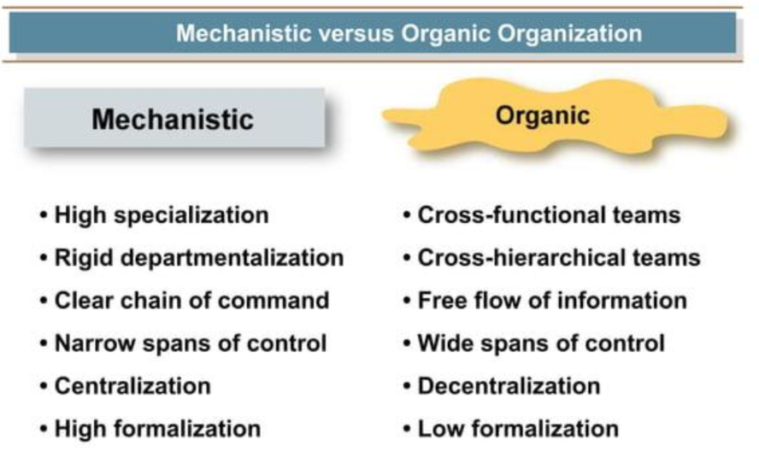

**Strategy and Structure**

* **Organic Structure:**
  + Works well for organizations pursuing innovation due to its flexibility and free-flowing information.
  + **Example:** Companies like Google use organic structures to encourage creativity and adaptability.
* **Mechanistic Structure:**
  + Suitable for companies aiming to tightly control costs due to its efficiency and stability.
  + **Example:** Traditional banks often use mechanistic structures to maintain strict control over financial operations.

**Technology and Structure**

* Organizations adapt their structures based on the routine nature of their technology.
  + **Routine Technology:** More mechanistic structures are suitable as they support standardized processes.
  + **Non-Routine Technology:** Organic structures are more appropriate as they allow for flexibility and innovation.
* **Example:** Nike, with its focus on innovation and digital transformation, likely employs an organic structure to support its e-commerce and digital engagement strategies.

**Environment and Structure**

* **Stable Environments:** Mechanistic designs are effective due to their emphasis on control and efficiency.
* **Uncertain Environments:** Organic designs are beneficial due to their flexibility and adaptability.

**Model vs. Structure**

* **Model:** A conceptual framework outlining how an organization should operate, including key processes and resource allocation.
* **Structure:** The actual hierarchy and division of roles within an organization, detailing reporting lines and information flow.

**Traditional Organizational Designs**

1. **Simple Structure:**
   * **Characteristics:** Low departmentalization, wide spans of control, centralized authority, and little formalization.
   * **Suitable For:** Small organizations and startups.
   * **Example:** A newly established tech startup might use a simple structure to keep operations lean and flexible.

1. **Functional Organizational Structure:**
   * **Characteristics:** Organized by departments based on specific skills and expertise (e.g., HR, Marketing, Finance).
   * **Example:** A manufacturing company with separate departments for production, sales, and finance.

1. **Divisional Structure:**
   * **Characteristics:** Composed of separate business units or divisions, each with limited autonomy.
   * **Advantages:**
     + Fast response and flexibility in unstable environments.
     + Fosters concern for customer needs and specialization in products/services.
   * **Disadvantages:**
     + Duplication of resources.
     + Poor coordination across divisions.
   * **Example:** The Walt Disney Company uses a divisional structure to manage its diverse operations in entertainment, media, and theme parks.

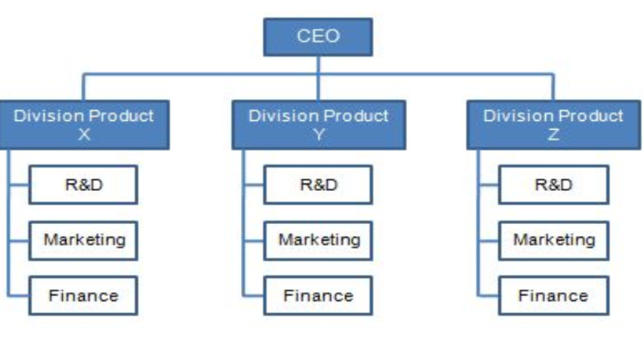

**Contemporary Organizational Designs**

1. **Matrix Structure:**
   * **Characteristics:** Combines functional and divisional structures, with employees reporting to two bosses (functional and product/project).
   * **Benefits:** Drives cross-disciplinary collaboration and innovation.
   * **Example:** Nike uses a matrix structure to facilitate communication across teams and enhance flexibility for regional markets.
2. **Team Structures:**
   * **Characteristics:** The entire organization is made up of work teams responsible for designing and executing work.
   * **Example:** Companies like Amazon and Hewlett-Packard use team structures to improve productivity and innovation.

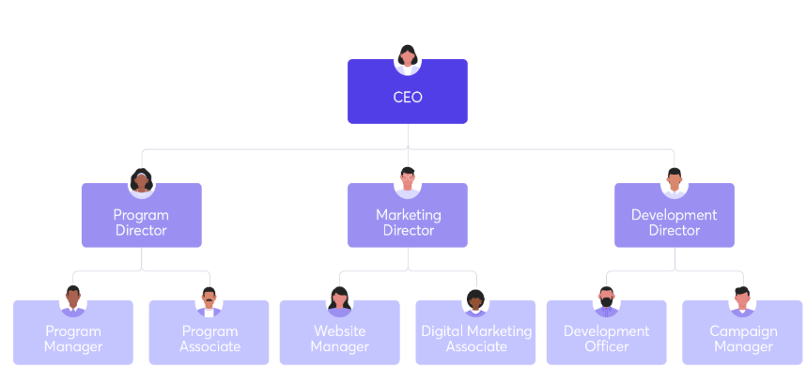

**Questions**

**Case Study 1: Choosing the Right Organizational Structure**

**Case Description:**

A mid-sized manufacturing company is considering a shift from a mechanistic to an organic organizational structure to foster innovation and adaptability. The company operates in a rapidly changing industry with frequent technological advancements.

**Question 1:**

What are the potential benefits of adopting an organic structure for this manufacturing company?

**Answer**:

Adopting an organic structure can provide several benefits:

- Flexibility: The company can respond more quickly to industry changes and technological advancements.

- Innovation: An organic structure encourages cross-functional collaboration and creativity, which can lead to innovative solutions.

- Employee Engagement: Decentralized decision-making and participative approaches can enhance employee engagement and job satisfaction.

**Question 2:**

What challenges might the company face during the transition from a mechanistic to an organic structure?

**Answer**:

The company might face challenges such as:

- Resistance to Change: Employees accustomed to a mechanistic structure may resist the shift to a more flexible and less formalized environment.

- Coordination Issues: Ensuring effective communication and coordination in a decentralized structure can be challenging.

- Resource Allocation: Managing resources efficiently in a more fluid structure may require new strategies and systems.

**Case Study 2: Technology and Organizational Structure**

**Case Description:**

A tech company specializing in software development is evaluating its organizational structure. The company's technology is highly non-routine, requiring frequent updates and adaptations to meet client needs.

**Question 1:**

Given the nature of the company's technology, which organizational structure would be most suitable?

**Answer:**

An organic structure would be most suitable for this tech company. The non-routine nature of its technology requires flexibility, adaptability, and continuous innovation, which are best supported by an organic structure.

**Question 2:**

How can the company ensure effective coordination and communication in an organic structure?

**Answer:**

The company can ensure effective coordination and communication by:

- Implementing Cross-Functional Teams: Encouraging collaboration across different departments to share expertise and innovate.

- Utilizing Collaboration Tools: Leveraging technology to facilitate communication and project management.

- Regular Meetings and Updates: Holding frequent meetings to align goals, share progress, and address any issues promptly.

**Case Study 3: Matrix Structure in a Multinational Corporation**

**Case Description:**

A multinational corporation is considering implementing a matrix structure to better manage its global operations and projects. The company operates in various countries with diverse product lines.

**Question 1:**

What advantages can a matrix structure offer this multinational corporation?

**Answer**:

A matrix structure can offer several advantages:

- Enhanced Coordination: Facilitates communication and coordination across different functional areas and geographic regions.

- Resource Optimization: Allows for efficient allocation and utilization of resources across projects and departments.

- Innovation: Encourages cross-disciplinary collaboration, leading to innovative solutions and improved problem-solving.

**Question 2:**

What potential challenges might arise from implementing a matrix structure, and how can the company address them?

**Answer**:

Potential challenges include:

- Dual Reporting: Employees reporting to multiple managers can lead to conflicts and confusion. This can be addressed by ensuring clear communication and coordination between managers.

- Complexity: The structure can be complex to manage, requiring robust systems and processes to support it. Regular training and clear guidelines can help manage this complexity.

- Power Struggles: Conflicts may arise between functional and project managers. Establishing clear roles, responsibilities, and decision-making processes can mitigate these issues.

**Case Study 4: Organizational Design in a Stable Environment**

**Case Description:** A well-established utility company operates in a stable and predictable environment with minimal technological changes. The company is considering whether to maintain its current mechanistic structure or shift to an organic structure.

**Question 1:** What are the advantages of maintaining a mechanistic structure in this scenario?

**Answer:** Maintaining a mechanistic structure offers several advantages:

* **Efficiency:** Mechanistic structures are efficient in stable environments, allowing for standardized processes and tight cost control.
* **Clarity:** Clear lines of authority and well-defined roles help in maintaining order and discipline.
* **Consistency:** High formalization ensures consistent performance and adherence to established procedures.

**Case Study 5: Implementing a Team Structure**

**Case Description:** A software development firm is considering transitioning to a team-based structure to enhance productivity and innovation. The company currently operates with a traditional hierarchical structure.

**Question 1:** What are the key considerations for successfully implementing a team structure in this firm?

**Answer:** Key considerations include:

* **Empowerment:** Ensuring that teams have the autonomy to make decisions and are held accountable for their performance.
* **Training:** Providing training to help employees adapt to the new structure and develop the necessary skills for teamwork.
* **Communication:** Establishing clear communication channels to facilitate collaboration and information sharing across teams.

**Question 2:** What potential challenges might arise from transitioning to a team structure, and how can they be mitigated?

**Answer:** Potential challenges include:

* **Resistance to Change:** Employees may resist the shift from a hierarchical to a team-based structure. This can be mitigated through effective communication and involvement in the transition process.
* **Coordination Issues:** Ensuring effective coordination among teams can be challenging. Implementing regular team meetings and using collaboration tools can help address this.
* **Accountability:** Ensuring that teams are held accountable for their performance without a traditional hierarchical structure. Clear performance metrics and regular reviews can help maintain accountability.